14th May 2018

Dear Parents/Carers,

Superheroes’ Day Celebrations Friday 15th June 2018

We are looking forward to celebrating the wonderful fathers, step fathers, grandfathers, uncles, brothers and superhero figures in our lives in a series of special “Superheroes’ Day” assemblies on Friday 15th June.

It would be fantastic if fathers, carers, uncles, grandfathers, brothers or any male role models who are special to your child could attend our celebrations.

The celebrations are on a staggered timetable:

9.00am - Reception Classes (Rousseau and Cezanne) in their classrooms

9.15am - Years 1 and 2 in the main hall

9.45am – Years 3 and 4 in the main hall

11.15am - Morning Nursery in Nursery classroom

12.30pm - Afternoon Nursery in Nursery classroom

2.45pm - Years 5 and 6 in the main hall

Yours sincerely
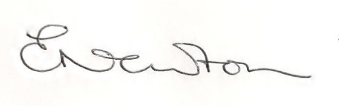
Emily Newton
Headteacher

