13th March 2018
Dear Parents and Carers
Parent/Carer Forum Thursday 20th March 2018 at 9am
We would like to invite you to our Parent/Carer Forum which takes place on Tuesday 20th March 2018 at 9am. Please note this meeting is at 9am this time instead of 2pm to allow a range of parents to attend.
We are on a relentless drive for excellence at King Athelstan and would like your input to support us on this journey. Members of the Senior Leadership Team and the Governing Body will be in attendance to discuss your views.

In order to set the agenda please could you record any issues you would like to be discussed at the Forum. Issues must relate to the whole school or Key Stage and not be particular to a class or individual. The most popular items will be chosen for discussion.

Yours sincerely
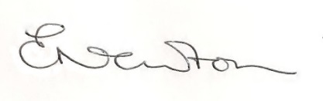
Emily Newton
Headteacher

--------------------------------------------------------------------------------------------------------------------------

Parent/Carer Forum 20th March 2018

I/we will be attending the Parent/Carer Forum on Tuesday 20th March 2018 at 9am:

Name: _________________________________ Child’s Name: ________________________________

Item(s) I would like to raise at Parent/Carer Forum:

- _____________________________________________________________________________
- _____________________________________________________________________________
- _____________________________________________________________________________
Please hand into the school office or email to Anita at: admin@kingathelstan.rbksch.org
Thank you

