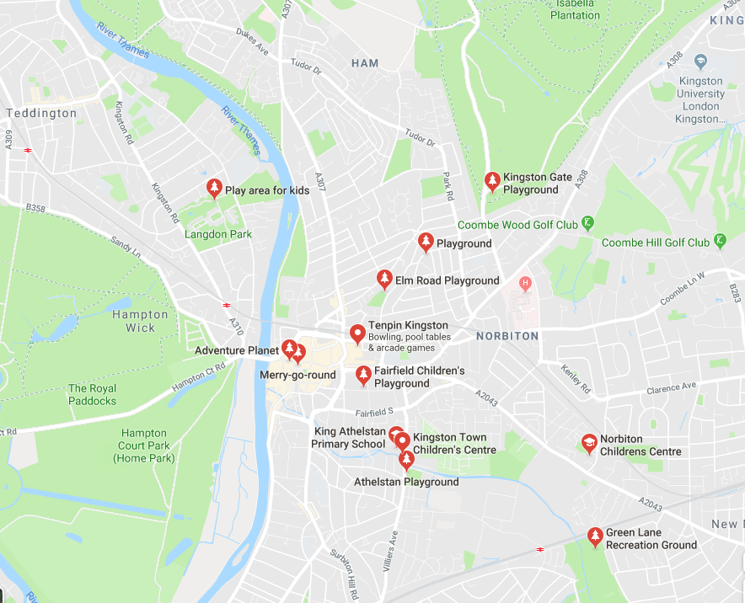
Parks and Playgrounds near King Athelstan Primary School
Richmond Park
Bushy Park

