King Athelstan Reading Scheme
At King Athelstan our aim is to foster a love of reading as children start on their reading journey, therefore our reading scheme reflects a diverse range of publishers, and in turn, a variety of characters, real and illustrated images and genres for our children to enjoy.
To provide our children with this broad range of texts we have carefully matched each scheme (including Big Cat, Songbirds, Oxford, Rigby Star and Phonics Books) to our own criteria, which is inextricably linked to our phonics scheme progression. Pocket Rocket Readers are also used alongside Read Write Inc. and reading scheme books in reception to ensure sounds taught in school are being practised at home.
Reading Scheme Criteria:
*Reading Age and Sonar Level are a guide for assessment - teacher assessment of comprehension skills should be used alongside these guides.
Lilac |  | Nursery/ Reception
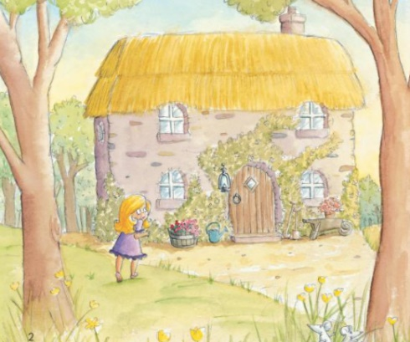 |  | Lilac books are wordless books that tell stories or give information through pictures and are designed to develop understanding about how stories and information books work.
 |  | Reading Age* | Sonar Level*
 |  | 3-4 | N – R
Pink |  | Reception - Autumn
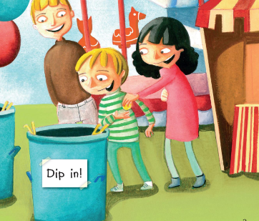 | Link to RWI:  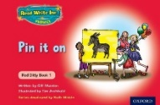 | Pink books offer emergent readers very simple text supported by illustrations. They use CVC words (with no digraphs).  Pink/Grey books offer emergent readers simple, predictable text with familiar objects and actions – these can be words with sounds not taught yet. Children should not try to ‘sound out’ these words and should use picture cues to support reading.
 |  | Reading Age* | Sonar Level*
 |  | 3-5 | RB
Red |  | Reception – Spring
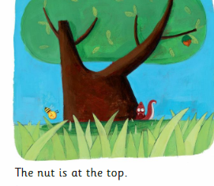 | Link to RWI:  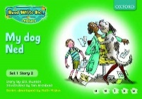 | Red books offer predictable text with familiar objects and actions, combined with simple story development. They use CVC words including some consonant digraphs and high frequency (tricky/red) words.  Red/ Grey books are as above, including words with sounds not yet taught. Children should not try to ‘sound out’ these words and should use picture cues to support reading.
 |  | Reading Age* | Sonar Level*
 |  | 4-5 | RB
Yellow |  | Reception – Summer
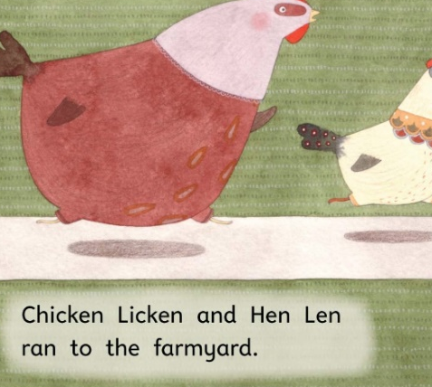 | Link to RWI:  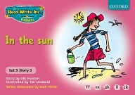  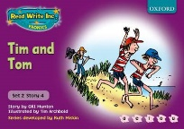 | Yellow books offer varied sentence structure and natural language. They introduce compound words, multi syllabic words, high frequency (tricky/red) words and include vowel digraphs taught in reception.  Yellow/ Grey books are simple in their sentence structure, often repetitive and include some digraphs not taught in reception e.g. split digraphs and ai, oa, ow.
 |  | Reading Age* | Sonar Level*
 |  | 4-5 | R JA/ R At
Blue |  | Year 1 – Autumn
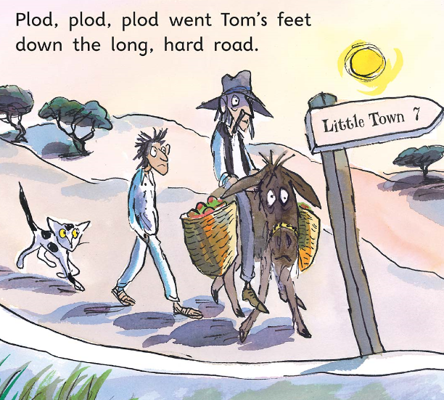 | Link to RWI:  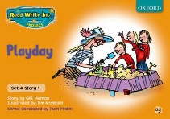 | Blue books offer longer, repeated patterns with sequential events and integrated literary and natural language. They include compound words, multi syllabic words, high frequency (tricky/red) words and consonant and vowel digraphs taught in the autumn term of Year 1, following the RWI progression.
 |  | Reading Age* | Sonar Level*
 |  | 4-6 | R At/ 1B
Green |  | Year 1 – Spring
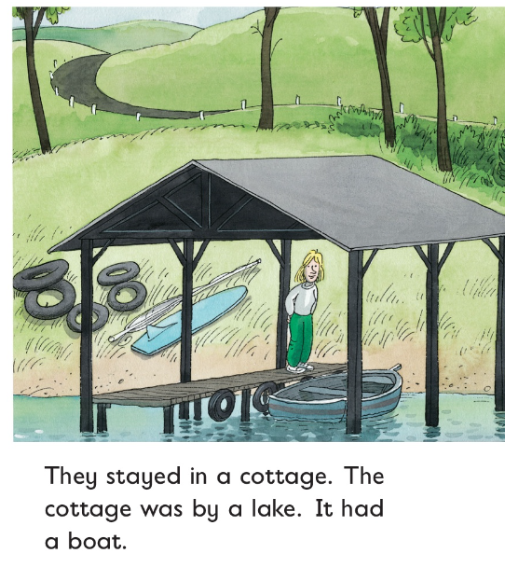 | Link to RWI:  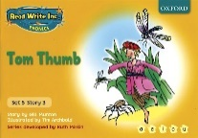 | Green books offer early readers patterned language and varied characters. Green books offer a larger volume of text per page (often two to three sentences) to begin to develop fluency (moving away from sounding out each word and recognising more words on sight). They use words with alternative spellings taught in Year 1.
 |  | Reading Age* | Sonar Level*
 |  | 5-6 | 1B
Orange |  | Year 1 – Summer
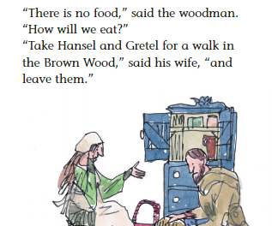 | Link to RWI:  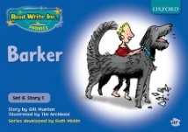 | Orange books offer varied text and characters, with action sustained over several pages. They continue to offer a larger volume of text per page (often three to four sentences per page) to begin to develop fluency (moving away from sounding out each word and recognising more words on sight). They use words with alternative spellings taught in Year 1.
 |  | Reading Age* | Sonar Level*
 |  | 5-6 | 1B/ 1 JA
Turquoise |  | Year 2 Autumn
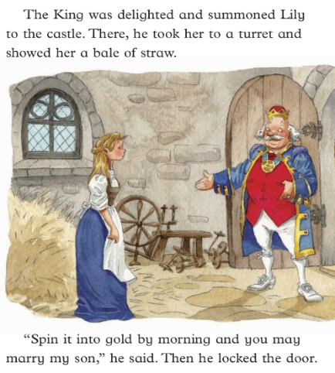 | Link to RWI:  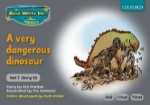 | Turquoise books offer literary language and extended descriptions, with longer sentences and a wide range of unfamiliar terms. They continue to offer varied text and characters, with action sustained over several pages, to begin to develop more confidence with fluency, with children reading most words by sight.
 |  | Reading Age* | Sonar Level*
 |  | 5-7 | 1 At / 2B
Purple |  | Year 2 – Spring
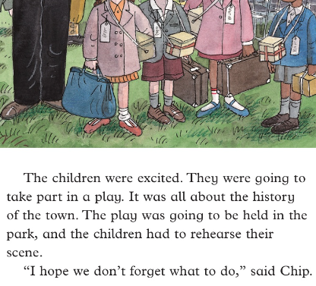 | Link to RWI:  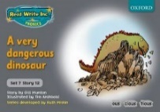 | Purple books offer developing readers literary language with some challenging vocabulary, as well as extended sentences and descriptions. Children should read purple books with confidence and expression, beginning to build stamina for longer reads.
 |  | Reading Age* | Sonar Level*
 |  | 6-7 | 1A / 2B
Gold |  | Year 2 – Summer
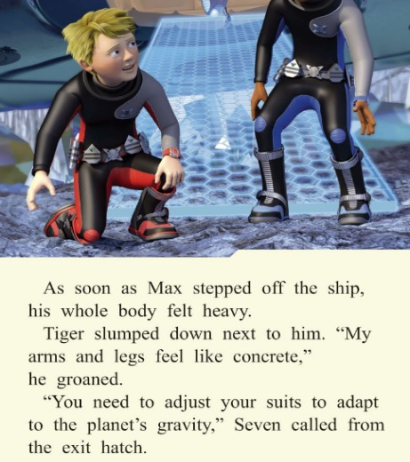 |  | Gold books offer developing readers literary language and stories with distinctive characters, who develop throughout the text, challenging vocabulary and extended sentences and descriptions. They build on purple books with some books providing simple chapters and a higher word count.
 |  | Reading Age* | Sonar Level*
 |  | 6-7 | 2 JA/ 2 At
White |  | Year 3 – Autumn
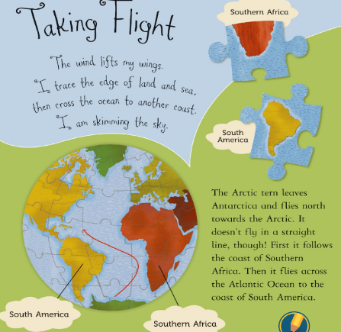 |  | White books provide confident young readers with more complex sentences and figurative language. They continue to introduce individual characters allowing children to reflect on and resonate with their actions and emotions.
 |  | Reading Age* | Sonar Level*
 |  | 6-7 | 2A/3B
Lime |  | Year 3 – Spring
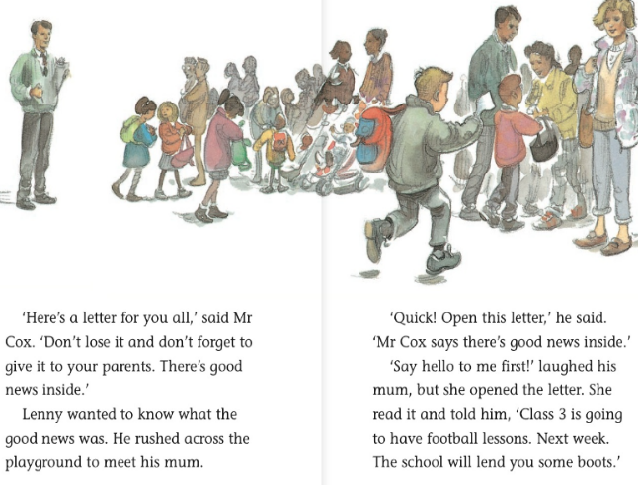 |  | Lime books have longer sentence structures and a greater use of literary language. Lime books require children to have sufficient comprehension skills to begin to infer meaning from more complex story lines and character relationships.
 |  | Reading Age* | Sonar Level*
 |  | 7-8 | 3B/3JA
Copper |  | Year 3 – Summer
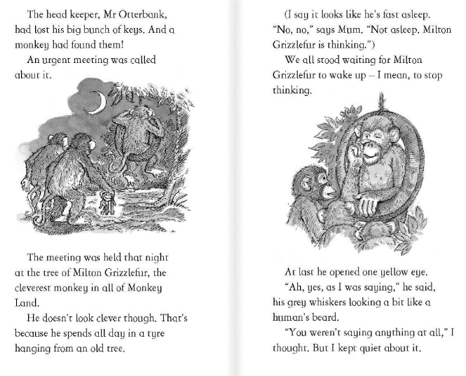 |  | Copper books provide more complex plots and longer chapters that develop reading stamina. They offer longer and more demanding reads for children to investigate and evaluate.
 |  | Reading Age* | Sonar Level*
 |  | 7-8 | 3At/ 4B
Topaz |  | Year 4 – Autumn
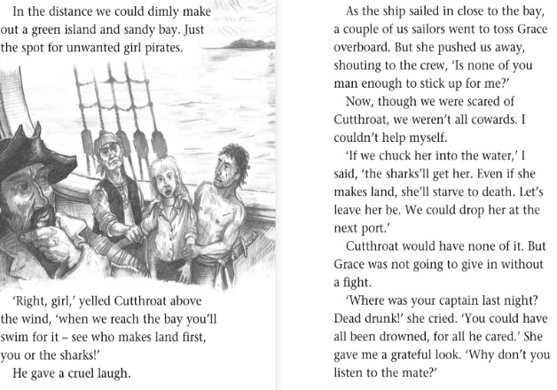 |  | Topaz books give increasing opportunities for children to develop their skills of inference and deduction. They offer more complex, underlying themes to give opportunities for children to understand causes and points of view.
 |  | Reading Age* | Sonar Level*
 |  | 7-8 | 3 A/4 B
Beyond the Reading Scheme |  | Reluctant Readers Years 4 - 6
The reading scheme continues with Ruby, Sapphire, Emerald, Diamond and Pearl; these books offer longer reads to develop children's sustained engagement with texts and are more complex syntactically. They provide a widening range of genres including science fiction and biography, prompting more ways to respond to texts. They present fluent readers a complex, substantial text with challenging themes to facilitate sustained comprehension, bridging the gap between a reading programme and longer chapter books, instilling confidence and fostering positive attitudes towards reading.  However, once children reach ‘Ruby’ on the reading scheme they are now ‘free readers’ and can dip in and out of the reading scheme, Bucket List, book corner and library books as and when they choose to, following guidance, advice and support from their class teacher. |  | 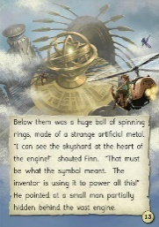  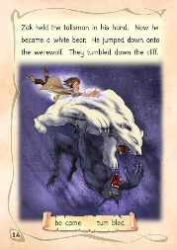  Our Reluctant Readers collection is aimed at KS2 children who are working out of band in reading; they are intended to develop the child’s love of reading (as they have age appropriate content and high interest story lines) but are written at an accessible level.  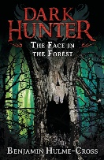  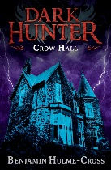
 |  | Appropriate age | Target Tracker Band*
 |  | 8-11 | 1B – 3 JA

